Site Application for Full Term AmeriCorps VISTA
2017-2018
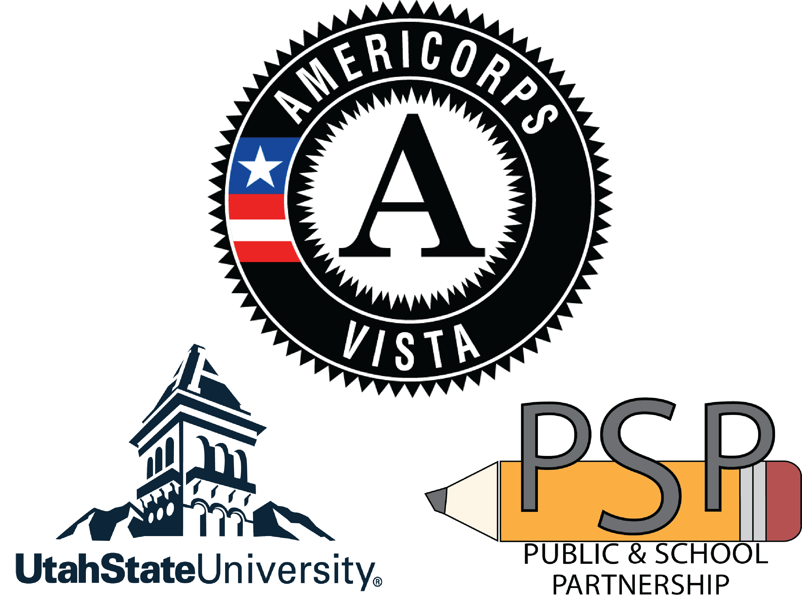

Full Term: 1 year (start date TBA)

Guidance

The Public & School Partnership’s (PSP) mission is to provide community members with access to the resources, education, and opportunities to elevate themselves and their neighbors out of poverty. In developing a plan for AmeriCorps VISTA programming that is in line with the Public & School Partnership’s mission, sponsors should incorporate activities that will result in a credible effort to help people move out of poverty. Full term VISTA members are discouraged from engaging in direct service activities; instead, full term members should engage in activities that help build organizational capacity and ensure program sustainability.

Full Term VISTA members receive:
- Living allowance of $990/month (half is paid twice per month)
- Paid personal & medical leave
- Health coverage option
- $5,815 Eli Segal AmeriCorps Education Award from the National Service Trust or a cash stipend of $1,500 upon completion of the service term
- Paid pre-service and in-service training and professional development opportunities
- Loan forbearance or deferment option

Basic eligibility criteria for Full Term VISTA members
- Must be at least 18 years of age at the time of placement
- Must be a U.S. citizen
- Must serve on a full-time basis during the project period
- Must not be listed on the National Sex Offenders Public Registry

If you are interested in a full-term PSP VISTA placement at your site please complete the following application by Friday, May 26th 2017 and e-mail the completed application to: pspvista.ut@gmail.com. Completed applications should be no more than 2 pages (not including this page). To complete the applications, click on the relevant text box and begin typing.

Name of site or organization:

- Are you a past AmeriCorps VISTA or other AmeriCorps host site? Please explain.

- Number of AmeriCorps VISTA members requested? (request not guaranteed)

- What is your plan for recruiting high-quality AmeriCorps VISTA members?

- Which disadvantaged populations does your school/community organization serve?

- Statement of the problem or challenge to be addressed by the work of AmeriCorps VISTA members. Please include the tie or effect on poverty. (For example, educational projects may help eliminate generational poverty by giving students and families the skills and credentials to increase earning potential.)

- Description of AmeriCorps VISTA member activities and projects they may work on.

- Describe how AmeriCorps VISTA members will be supervised at your site. Who will be the direct supervisor that will have the most contact with VISTA members? If there will be other full time VISTA or AmeriCorps members on site, what will be their relationship? (Different activities, similar activities, collaboration opportunities)

- Will any of the cost share contribution ($6,700) come from Trust Lands funds? If so, how will the VISTA member's work support the School Improvement Plan?

