AmeriCorps VISTA Public & School Partnership

Partner Information Sheet

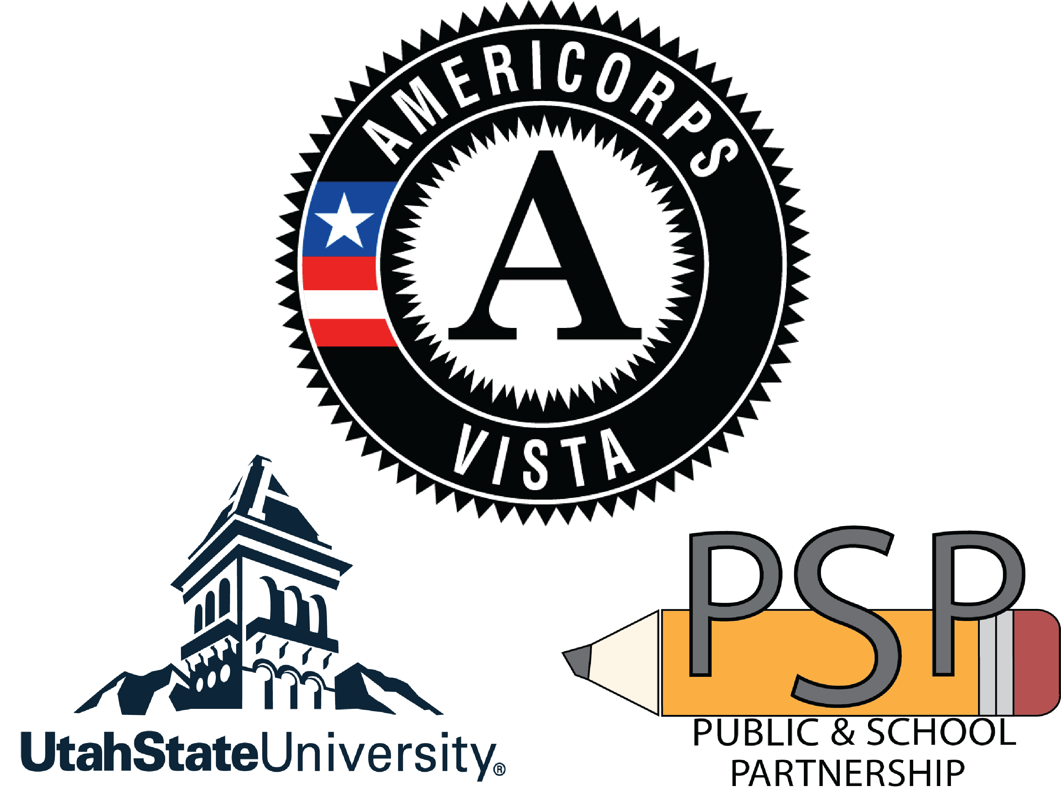

The Public & School Partnership (PSP) is an AmeriCorps VISTA grant program hosted at Utah State University. Through this grant, PSP recruits and places national service volunteers (VISTAs) to work within partnering organizations to focus on improving and expanding educational systems. PSP manages the grant, reporting, and hiring (based on partner organization recommendation).

The focus of the project is to help eradicate poverty in our communities through the promotion of educational initiatives. While the project is designed to improve the circumstances for all of Utah's students and families, specific grant activities strive to provide support for economically disadvantaged students and those at-risk for social and academic failure.

How does the program work?

A potential site can submit an application to host one or more VISTA Members; however, requests are not guaranteed. Upon approval of the application, the site and PSP will work together to recruit a qualified VISTA member. The VISTA Member reports directly to the project site (school or community organization) as a full-time (40 hours/week) volunteer for the contracted duration of one year. Renewal of the VISTA Member’s contract and/or the site’s VISTA slot is assessed each year and is based on availability within the grant and the discretion of PSP and the project site.

The VISTA Member work scope is centered around building capacity and creating sustainable programs within educational partnerships. VISTA Member activities should be based on increasing literacy, community connectedness, parent support, high school completion, college and career readiness, or other appropriate educational initiatives. The VISTA Member will address various needs of the project site through specific focus areas. Some of the specific areas of focus for VISTA projects include:

Developing and implementing training materials for staff and volunteers

Student screening and identification for needed services

Implementation of programs and services to benefit at-risk students and families

Management of data systems and data presentation for decision making

Resource generation and capacity-building activities

Volunteer recruitment, training, and management

Promotion of college and career readiness programs and activities

* VISTA Members are absolutely prohibited from proselyting or participating in any activity designed to influence the outcome of an election. VISTA Members also may not participate in any political activity while identifying themselves or their program with AmeriCorps VISTA or to participate in activity designed to influence passage or defeat of legislation. (See the Hatch Act for more information.)

What is required of participating partners and what support will we receive?

 | AmeriCorps (CNCS)  Federal Funding Agency | Public & School Partnership at  Utah State | Project Site (School or Community Organization) | VISTA Member
Provides | Medical coverage options for members  Life Insurance plan options  Childcare benefit  End of service Award: Education Award OR cash stipend | VISTA member living allowance and benefits  Administrative support services  Progress and financial reporting to CNCS  Training for VISTA members  Payroll and grant management services  Human resources support | $7,000 cost share  Professional work environment  Daily management  Orientation & training as needed  Program data for reporting  Allowances for VISTA leave  Program feedback and VISTA evaluations  Branding as appropriate  Signing and abiding by the project MOA | One-year commitment  40 hours per week  Mandatory attendance at PSO and PSP trainings and events  Program impact data for reporting  Participation in national days of service and other service projects  Completion of monthly reporting
Receives | Full time national service volunteers  Improved services for Utah Students  Reporting data | Continued grant funding for VISTA program  Lasting partnerships  Collaborative environments to develop and refine best practices  Recognition and support from administrative partners  Joint authorship (on collaborative efforts as appropriate) | Full time VISTA member on site  Access to PSP resources (staff, library, research, training materials, etc.)  Increased resources and grant activities  Improved services for at-risk students  Access to research opportunities and validated best practices | Monthly living allowance of $1042  Medical and pharmacy benefits  Child care and life insurance option  Paid training  Segal Education Award ($6,195) OR Cash stipend ($1,800) upon completion of service  10 personal and 10 medical leave days.

